**Instructions:**Replace **[bracketed red text]** with the requested information or screen capture.  
Replace **bracketed red text with black text**.  
**PLEASE do not include full page, full window screen shot images**, or full screen shots that have been reduced in size.   
Use a snippet tool to capture parts of the screen and insert those images into the template.  
**Do not remove tags from this template. An example of a tag is [C.1]. All fields are required.***Please do not alter template formatting or delete parts of this template.*

Part A - Student Information:   
 **1. Student Name: [A.1] [STUDENT NAME – Aamir, Patel]**

**2. What day and date did you start this assignment? [A.2] [Saturday 3/13/2020]**

Go back to the instructions and continue with Part B.

Part B –CMS Shared Webhost Information:

**1. Which shared web host did you use for this part of the assignment?**[B.1] **[Name Cheap]**

**2. Pantheon – Did you build a Pantheon Drupal site?**[B.2] **[No]**

B.1 New Drupal Site on your Shared Web Host:

1. **Assignment Website In-Directory Name:** [B.1.1]   
   **[Tutorial-10]**
2. Shared Web Host account username:   
   [B.1.2]  
   [ Aamir8567]
3. Shared Web Host account password:   
   [B.1.3]  
   [ Kamboli90123!]
4. **Assignment MySQL Database Information** [B.1.4]
   * **Database Name:** **[drup299]**
   * **Table Prefix:** **[drx4_]**
5. **WEBSITE Admin Username:** [B.1.5] **[aapadcpate]**
6. **WEBSITE Admin Password:** [B.1.6] **[9aIwR@LZB%#uk9Fgh3]**
7. **Tutorial Website URL:** [B.1.7] **[https://aamirpatel.tech/Tutorial-10/]**

Go back to the instructions and continue with Part C.

B.2 -OR- if you used Pantheon (PA) fill out the information below:

1. **Pantheon Account Info:** [B.2.1]
   * **Pantheon Account Email: [Your Pantheon Account Email]**
   * **Pantheon Password: [Your Pantheon Account Password]**
2. **Drupal Version major.minor.patch:** [B.2.2] **[Drupal Version]**
3. **Pantheon Site Name:** [B.2.3] **[SITE NAME]**
4. **WEBSITE Admin Username:** [B.2.4] **[ADMIN USERNAME]**
5. **WEBSITE Admin Password:** [B.2.5] **[ADMIN PASSWORD]**
6. **Pantheon site URL:** [B.2.6] **[Your Pantheon CMS Site URL]**

Go back to the instructions and continue with Part C.

Part C - Create a new previous version Drupal site on Codeanywhere

We want to build a Drupal previous patch version.   
It’s up to you to check drupal.org, find the most recent version of Drupal 9 and build the previous version.

1. What website URL did you review to get the most recent Drupal 9 core version major.minor.patch?   
   [C.1]  
   [ Website URL: http://ap-tutorial-10-mpate18024699.codeanyapp.com/]
2. What is the current Drupal 9 core version major.minor.patch?   
   [C.2]  
   [ major.minor.patch 9.1.5 ]
3. What version of Drupal 9 did you build?   
   [C.3]  
   [ major.minor.patch 9.1.4 ]
4. Enter the following Codeanywhere web host Drupal 9 site information   
   **[**C.4**]**
   1. Codeanywhere account username(email): [mpate180@depaul.edu]
   2. Codeanywhere account password: [Kamboli1!]
   3. Site Title: [ site title here ]
   4. Website Username: [ aapadcpate ]
   5. Website Password: [ 9aIwR@LZB%#uk9Fgh3]
5. BACKEND SCREEN CAPTURE – Site Status Report  
   Admin toolbar > Reports > Status report   
   Please make sure the General Systems Information block is complete visible in your screen capture   
   [C.5]   
   [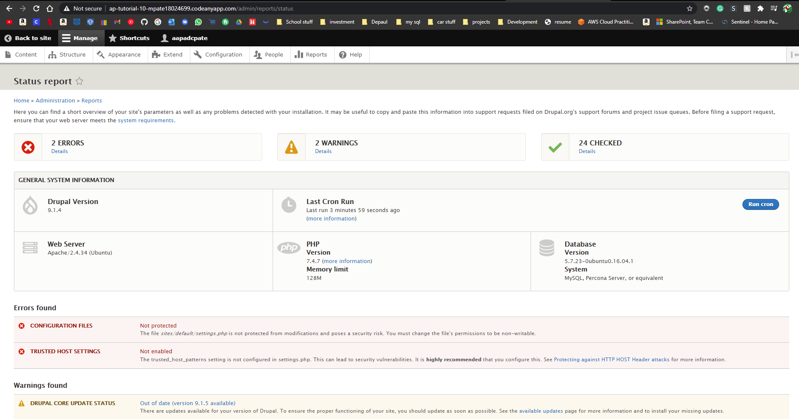]

Go back to the instructions and continue with Part D.

Part D - Updating Drupal – Updating Contrib Modules

1. What are the reasons you should keep your Drupal contrib modules up to date?   
   [D.1]  
   [ You want to keep the modules up to date because the developers have fixed bugs which in some cases, it can be catastrophic if you don’t update your modules. ]
2. List the procedure for installing your Drupal contrib module updates on a Drupal site?   
   [D.2]  
   [ First you want to go to admin tool bar > module > update > check for update.

Then create a backup of your website.

Then go back to admin tool bar > module > update > Put webpage in Maintenance mode > perform those updates.

]

1. SCREEN CAPTURE – Backend Available Updates Page  
   [Admin toolbar > Reports > Available Updates] page   
   Note – If you restored your Drupal site from a backup, please update the modules and then take the screen capture.  
   [D.3]   
   [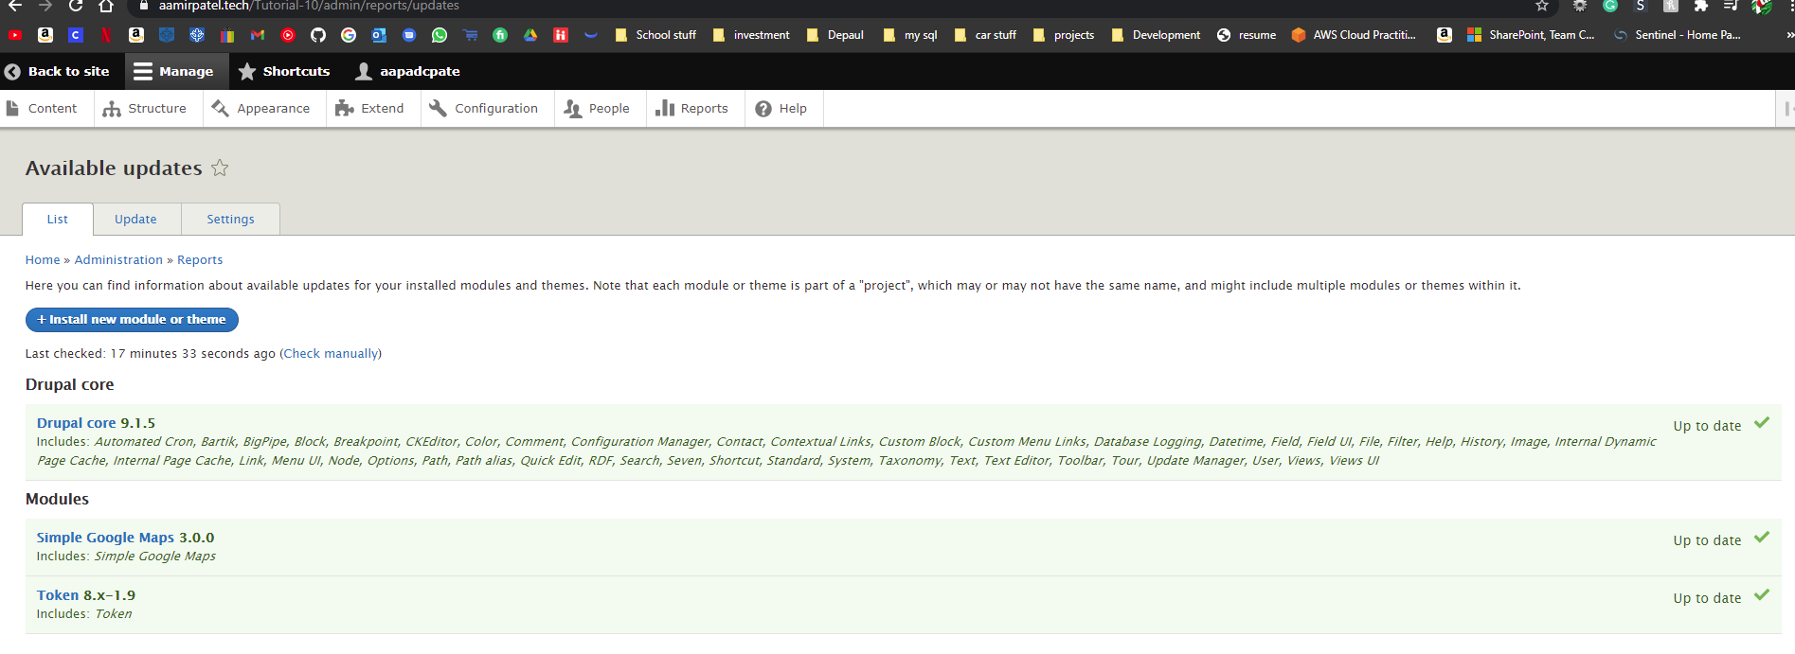]

Go back to the instructions and continue with Part E.

Part E– Updating Drupal – Minor Core Update

1. What are the reasons you should keep your Drupal website core up to date?   
   [E.1]  
   [ The primary reason of keeping Drupal site up to date is security, the Drupal team releases an update if they detect vulnerability in their code. Another reason is new features, Drupal is always improving so updating core version is important for you to get new features. ]
2. Were you able to successfully update your Codeanywhere Drupal site?

[E.2]  
[ Yes ]

1. If you were unable to successfully update your Codeanywhere Drupal site what went wrong and if possible, provide screen captures about the error?

[E.3]  
[ N/A ]

1. Backend SCREEN CAPTURE – Screen capture of the [Admin toolbar > Reports > Available Updates] page showing the Drupal version in the GENERAL SYSTEM INFORMATION block  
   [E.4]   
   [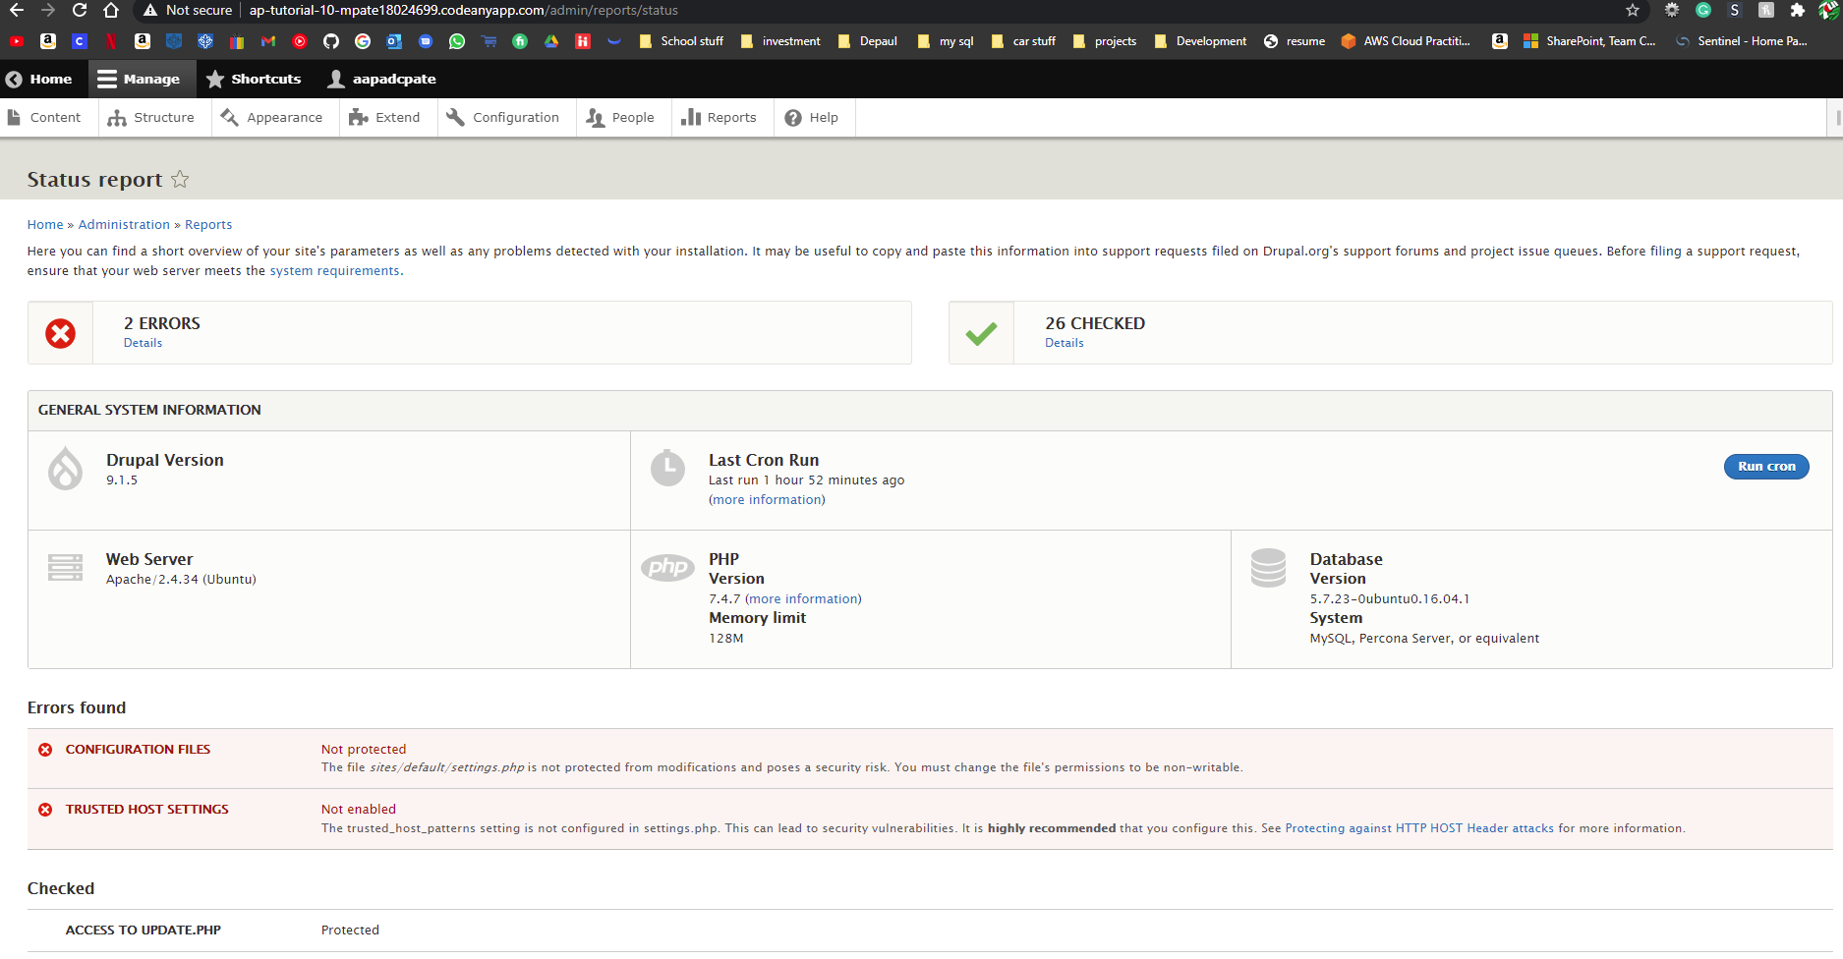]

Go back to the instructions and continue with Part F.

Part F – Drupal Backup Migrate – Demonstration  
  
Please answer the following questions about the Drupal Backup Migration process.

1. What are the reasons for using the Backup Migrate modules?   
   [F.1]  
   [ The reason we are using Backup and Migrate plugin is because it allows us to create backups of our database for drupal, along with migrating backups into the actual builds of the project. We can also use it to migrate platforms for the Drupal site.]
2. Before we ran the backup of the public database, we did two tasks, what were they and why did we do them?   
   [F.2]  
   [ We cleared the cache and deleted the logs, to lower the file size of our backup ]
3. What two (2) backup files were created during the backup process?  
   [F.3]  
   [ We created the backup files for Public Files Directory, and Default Drupal Database]
4. What are the two (2) backup files, created during the backup process contain?  
   [F.4]  
   [ Public Files Directory file contains all of the media, such as images / webpages / blocks and all the other stuff that the visitors sees. ]
5. What are the steps for restoring a Drupal site that has been created, has a matching core version to the public DB backup, and has the Backup migrate module installed and enabled?  
   [F.5]  
   [ The first step would be going to the backup migrate module > restore > Upload public files directory (first) > select restore to (public file directory) > Restore Now.

After public files, restore the database.

backup migrate module > restore > Upload Default Drupal Database file (second) > select restore to (Default drupal database) > Restore Now.

After uploading both, clear the cache.

]

Go back to the instructions and continue with Part G.

Part G– Drupal Workflow with GitHub

As web hosting changes to adopt GitHub and versioning, we will eventually integrate Drupal GitHub workflow into this class. Your feedback on the current workflow video series is an important part of this process.   
Please answer the following questions the Drupal GitHub workflow.

1. What aspects of the Drupal GitHub workflow were similar to our WordPress GitHub workflow?   
   [G.01]  
   [ The commands for uploading to wordpress were same. Pulling from repo commands were also same. Creating a new database account was also same]
2. What aspects of the Drupal GitHub workflow were different to our WordPress GitHub workflow?   
   [G.02]  
   [ In wordpress we did not have to change file settings to camod. We also did not have to copy the settings.php file.]
3. Were you able to follow along and understand what was happening in the videos? What aspects of the Drupal GitHub workflow were similar to our WordPress GitHub workflow?   
   [G.03]  
   [ Yes I was able to follow the videos, and the workflow for Drupal is very similar to workflow for Wordpress. The git pull, push was same. Also, the modifying of upload file was also same. ]
4. What is the purpose of the .gitignore file?  
   [G.04]  
   [ The .gitignore file prevents the uploading of sensitive files. ]
5. What files did we add to the .gitignore file?  
   [G.05]  
   [ We want to add all the file and paths of files that contains usernames and passwords, unencrypted backup files. ]
6. Why did we copy the sites/default/settings.php file?  
   [G.06]  
   [ Because it has all of the settings for the entire drupal website]
7. SCREEN CAPTURE – Backend screen capture of Admin toolbar > Reports > Available updates  
    [G.07]  
   [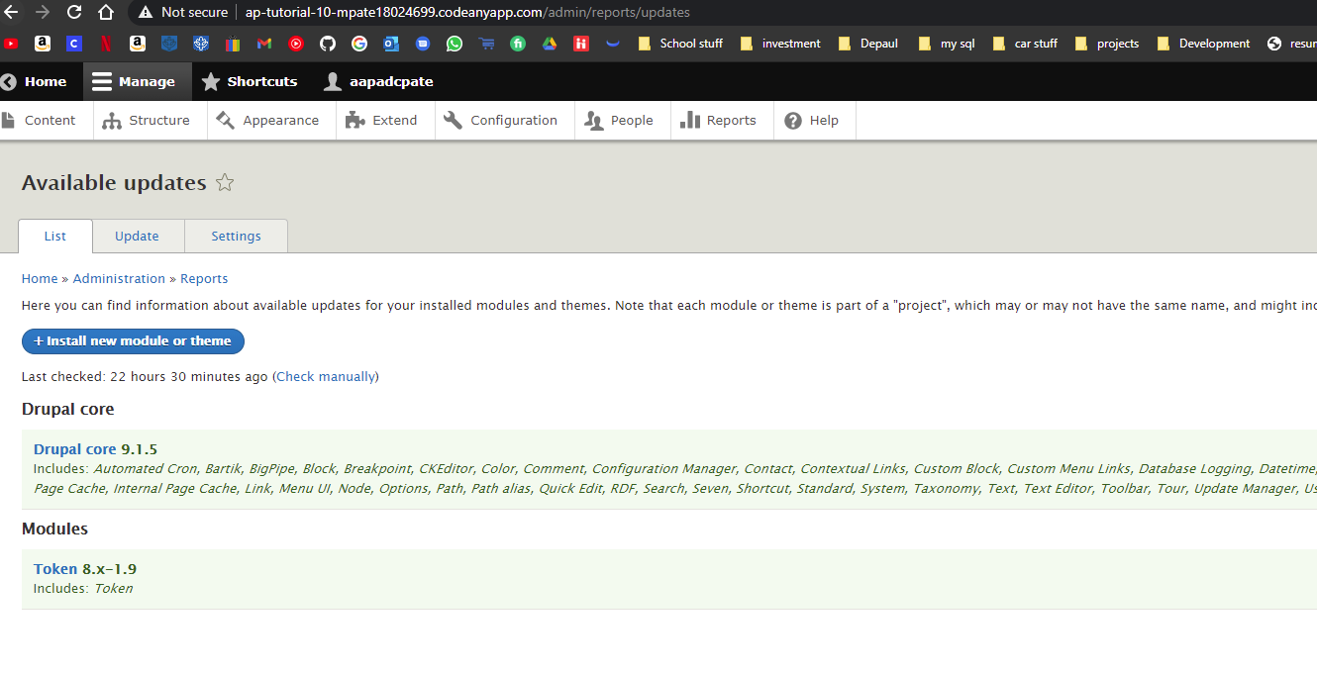]
8. SCREEN CAPTURE – Backend screen capture of Admin toolbar > People (list of accounts)   
   [G.08]  
   [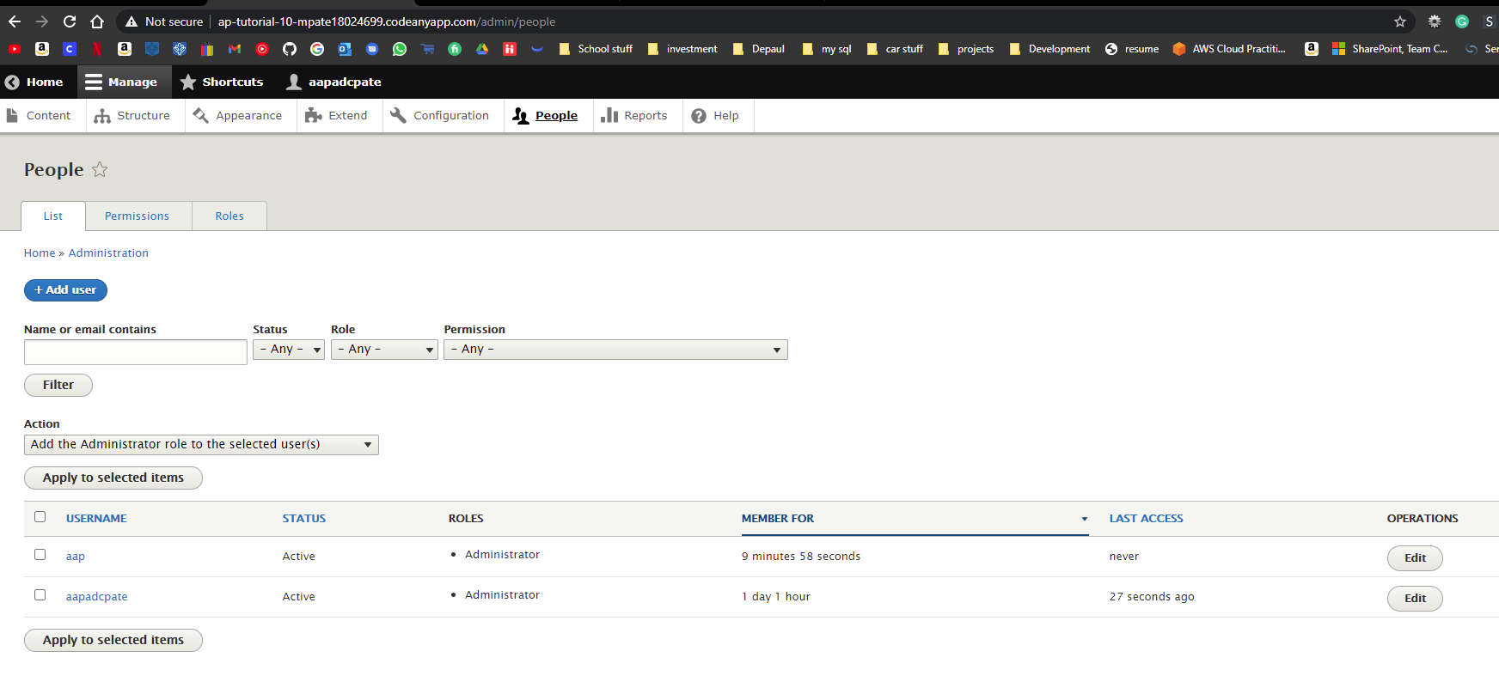]
9. SCREEN CAPTURE – Backend screen capture of Admin toolbar > Content (list of all site content) [G.09]  
   [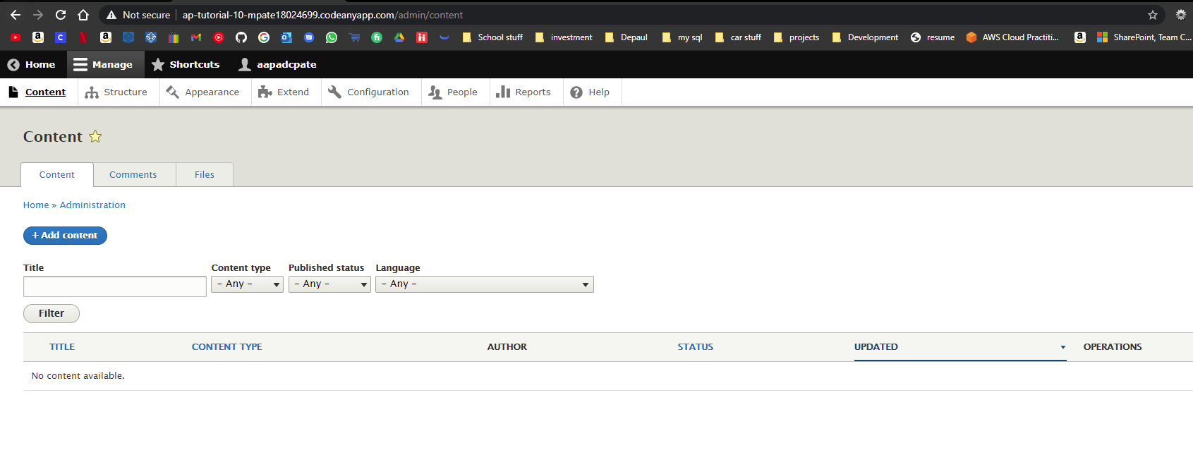]
10. SCREEN CAPTURE – Front-end Home Page showing the Web browser Address Bar and all the   
    front-page articles [G.10]  
    [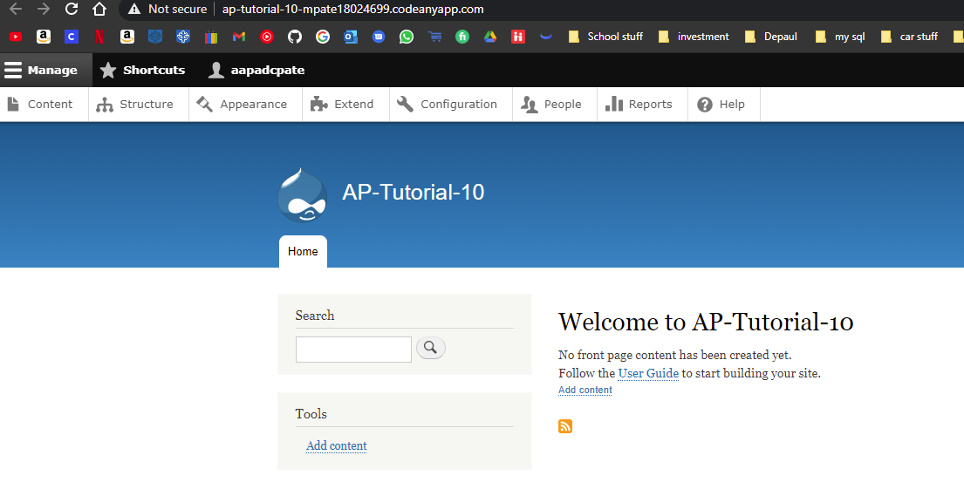]

Go back to the instructions and continue with Part H.

Part H – Media and Media Library

1. SCREEN CAPTURE – Backend screen capture of the media files uploaded to the site  
   Admin toolbar > Media, listing all the media files you added to the system[H01]   
   [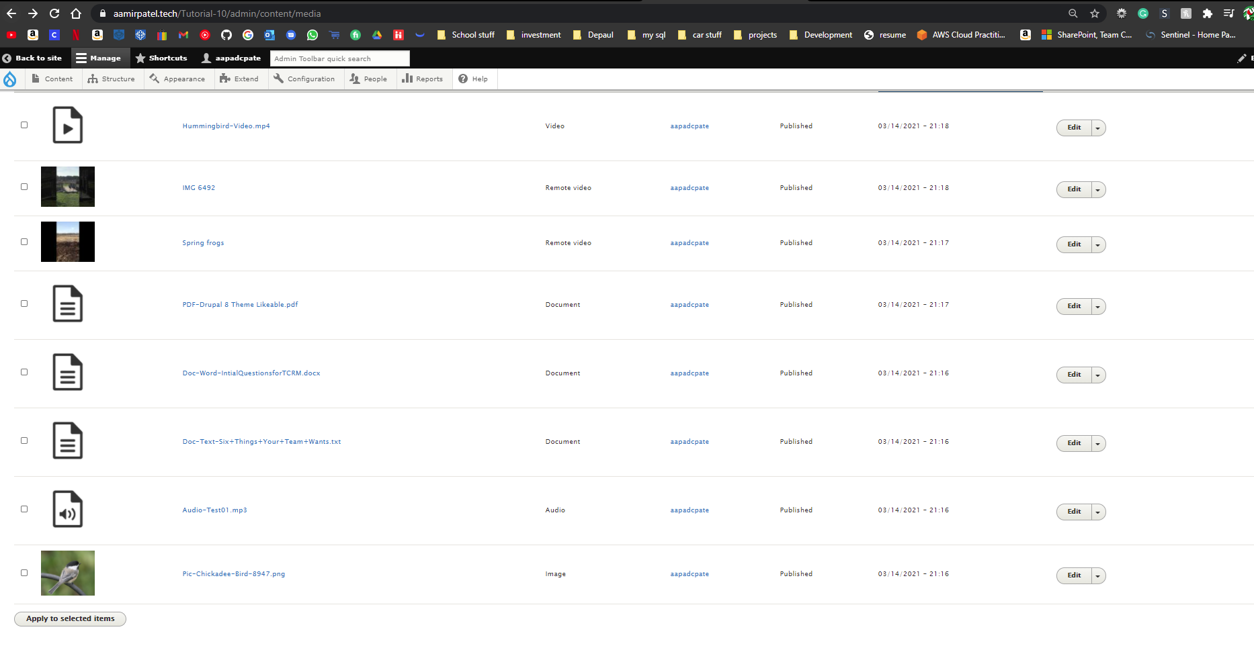]
2. SCREEN CAPTURE – Backend Modifications to the WYSIWYG  
   Admin toolbar > CONFIGURATION > CONTENT AUTHORING, Text formats and editors   
   SELECT basic HTML, CONFIGURATION OPTION  
   Screen capture with the TOOLBAR CONFIGURATION (Active toolbar) buttons visible

[H02]  
[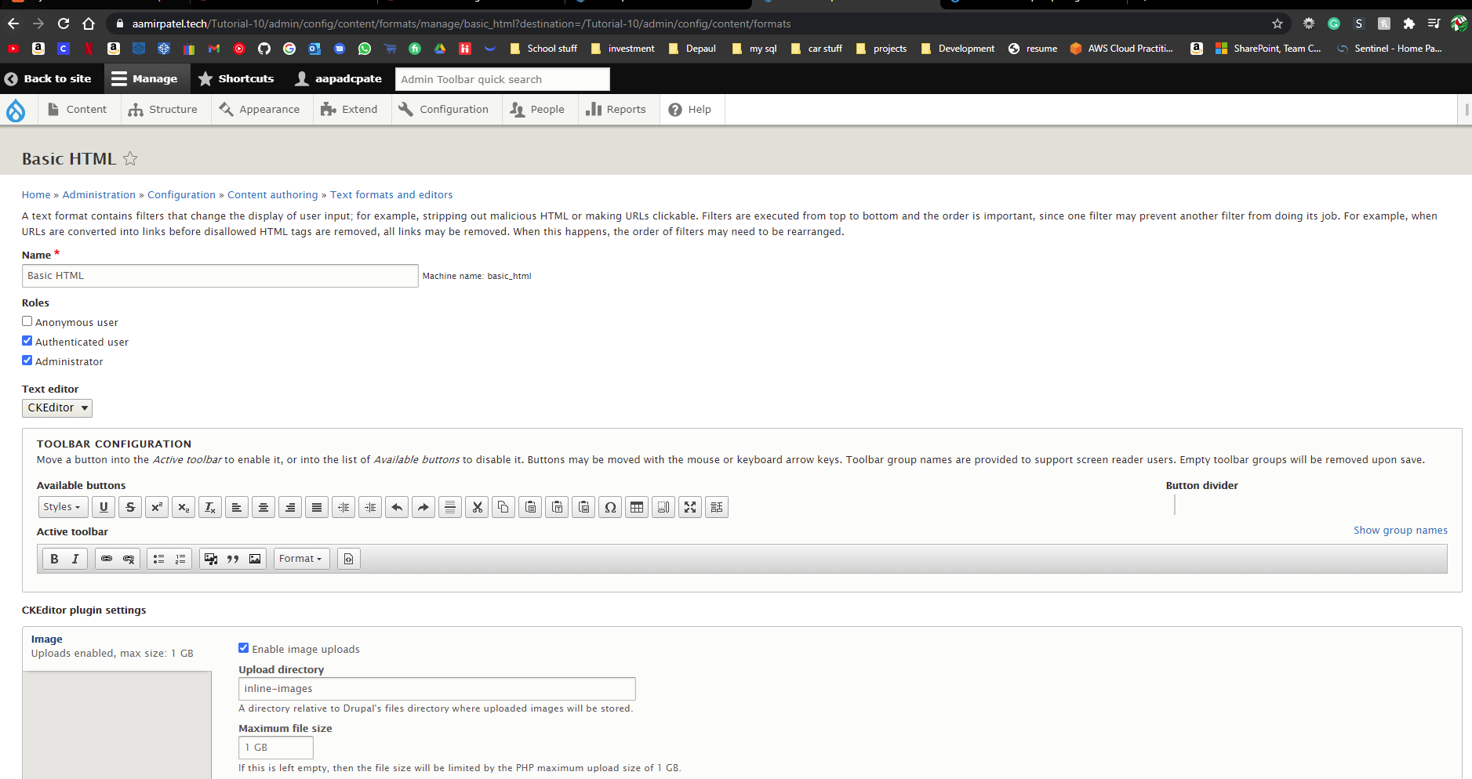]

1. SCREEN CAPTURE – Backend Modifications to the WYSIWYG  
   Admin toolbar > CONFIGURATION > CONTENT AUTHORING, Text formats and editors   
   SELECT full HTML, CONFIGURATION OPTION  
   Screen capture with the TOOLBAR CONFIGURATION (Active toolbar) buttons visible

[H03]   
[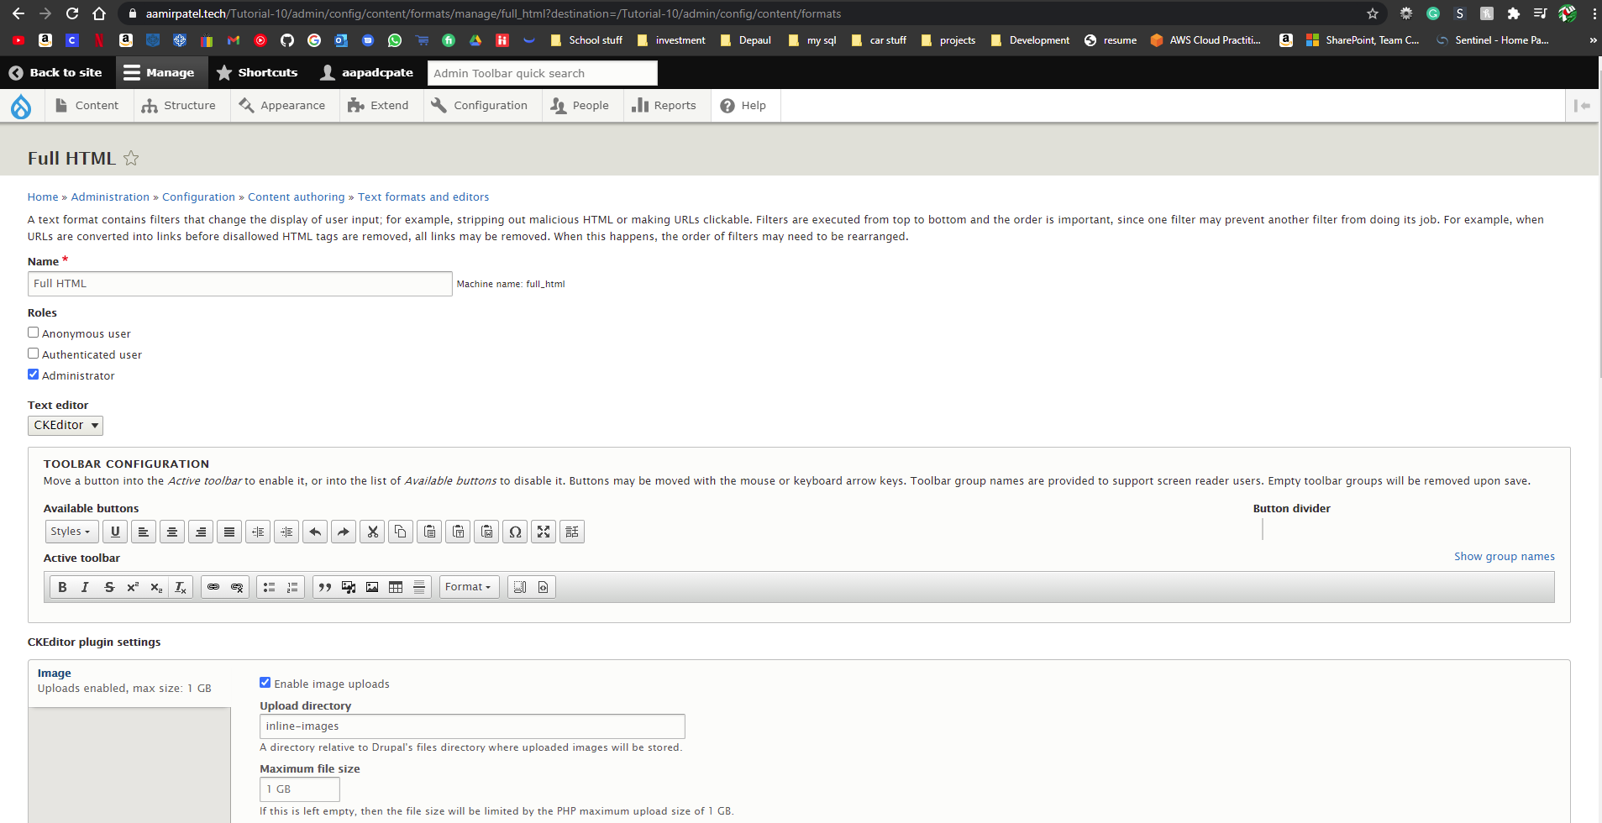]

1. SCREEN CAPTURE – Backend Modifications to the Article content type  
   ADMIN TOOLBAR > Structure > Content types, Select Articles OPERATIONS Manage fields   
   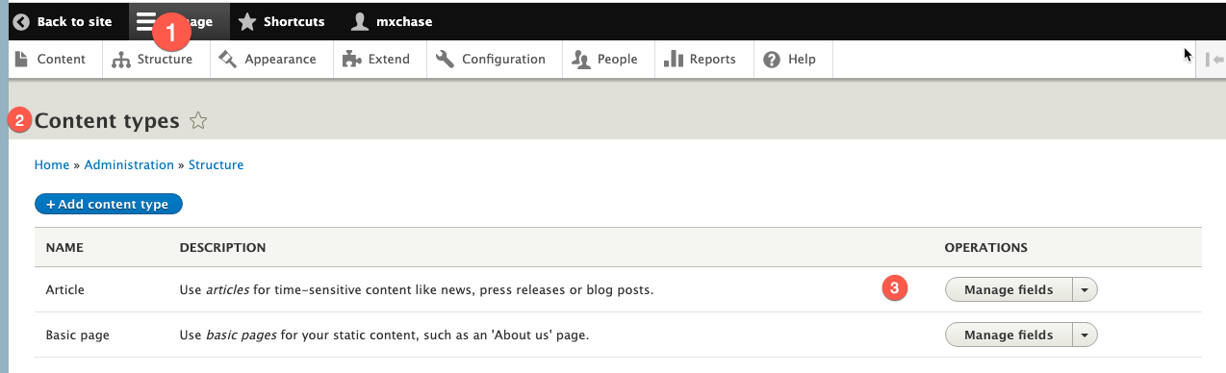

Take a screen capture of the Manage fields TAB page  
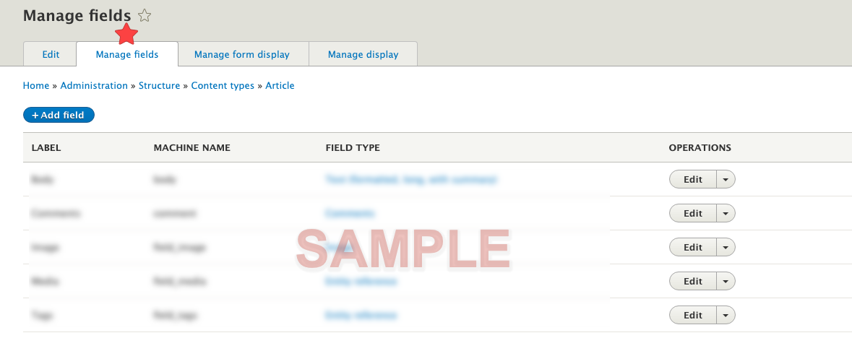

[H04]   
[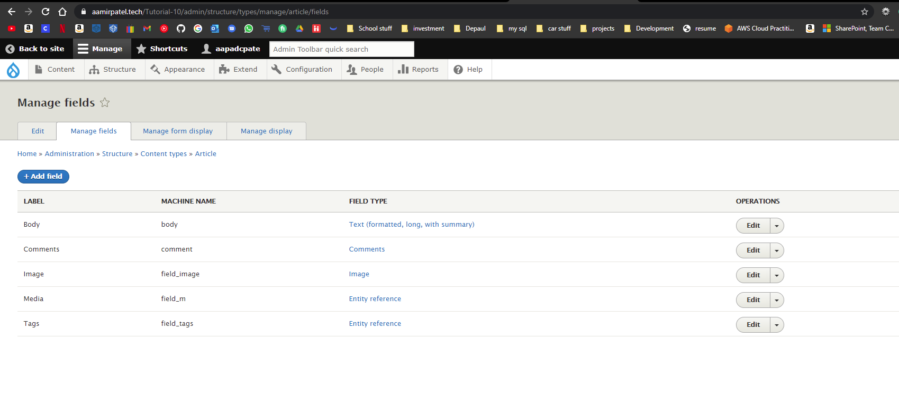]

1. SCREEN CAPTURE – Front end screen captures of the Home page showing the Articles teasers   
   [H05]  
   [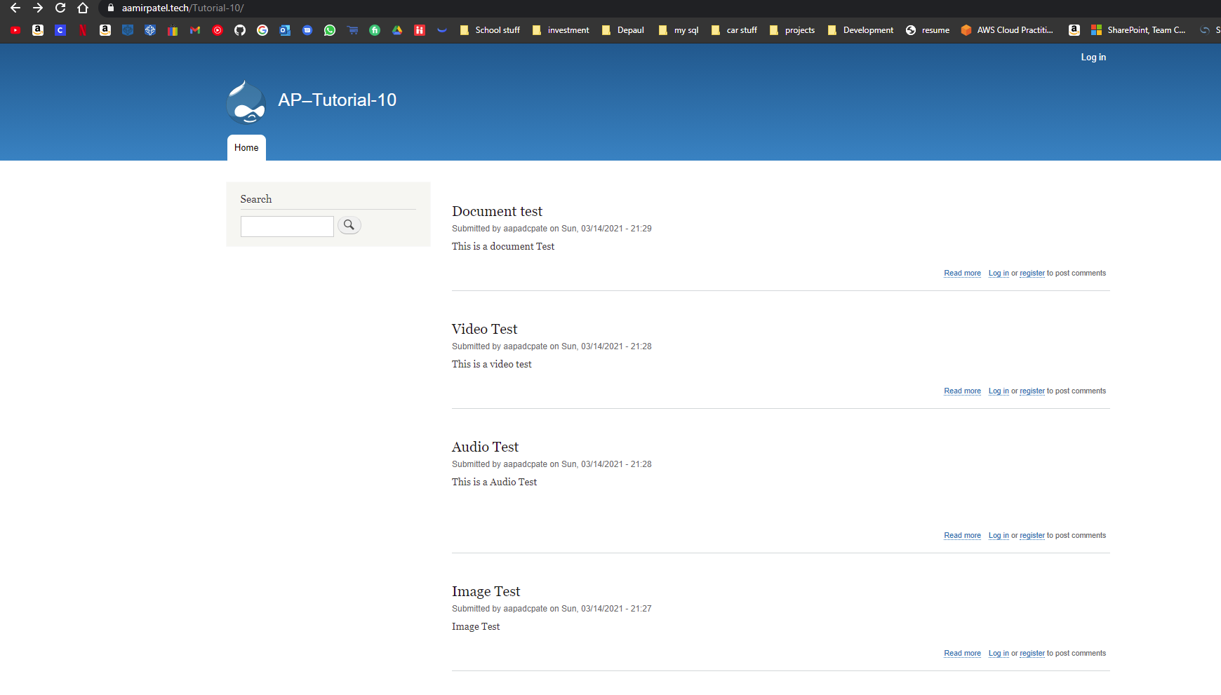]
2. SCREEN CAPTURE – Front end screen captures of the Articles added with their Media content visible [H06]  
   [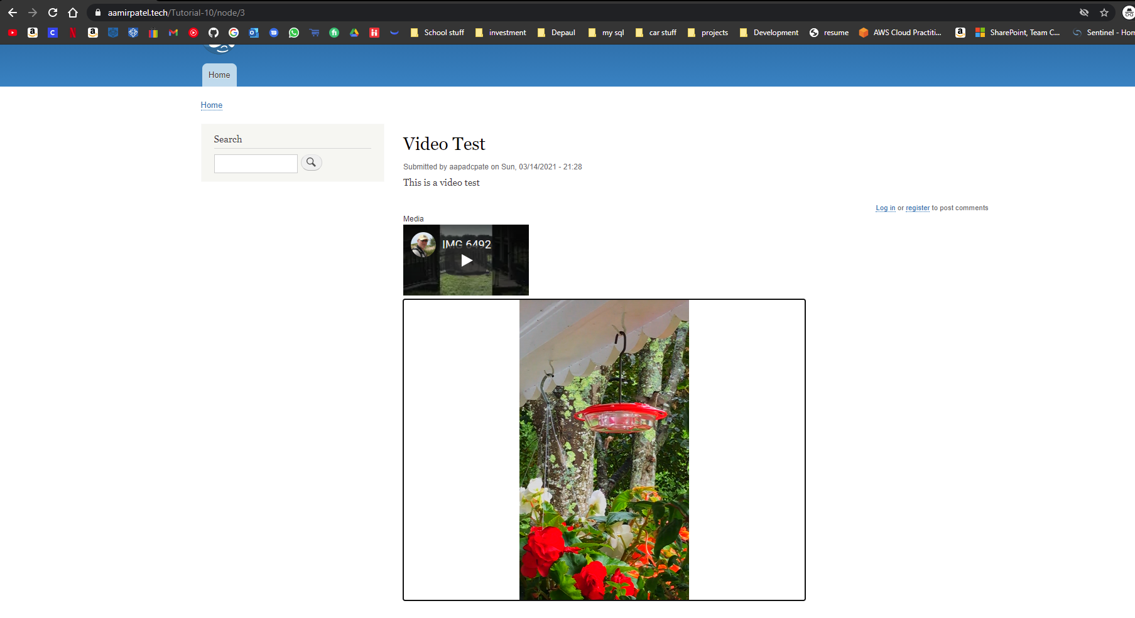]

**Congratulations! You have completed this tutorial.**